1. **CLASS DIAGRAM**

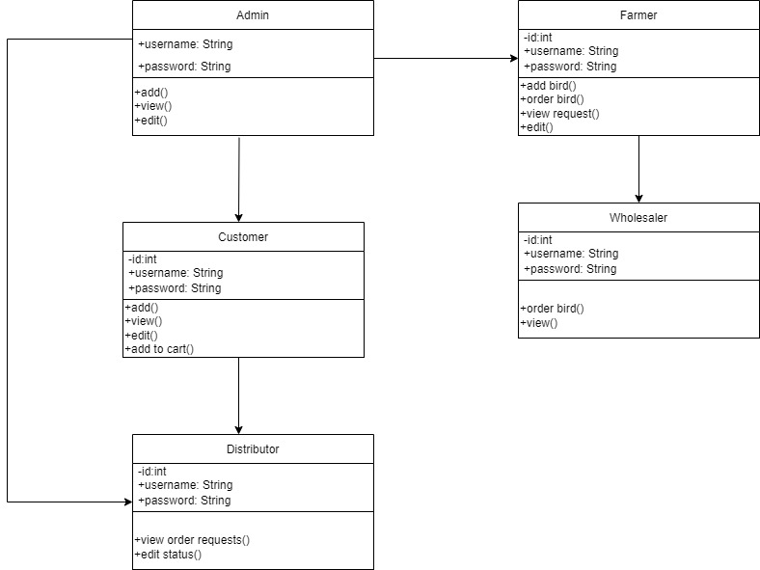

1. **OBJECT DIAGRAM**

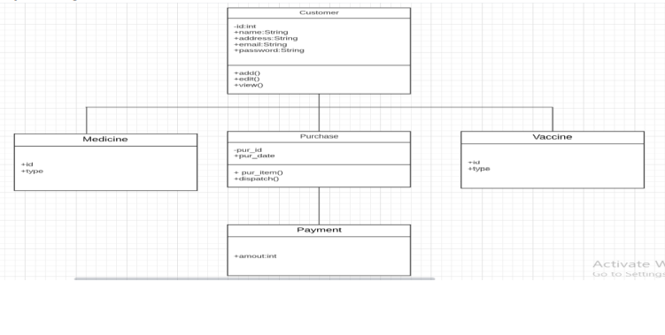

## USE CASE DIAGRAM

## 

## SEQUENCE DIAGRAM

## 

1. **COLLABORATION DIAGRAM**

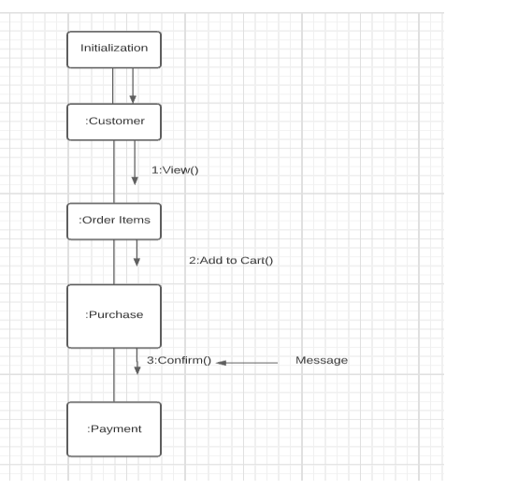

1. **ACTIVITY DIAGRAM**

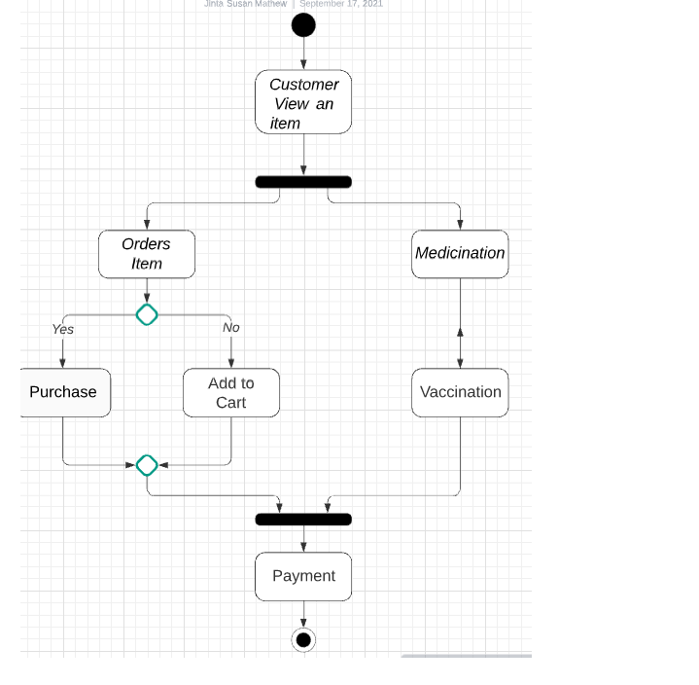**7. STATE CHART DIAGRAM**

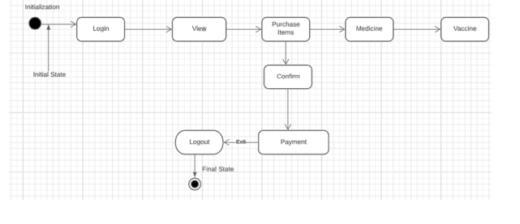

**8.DEPLOYMENT DIAGRAM**

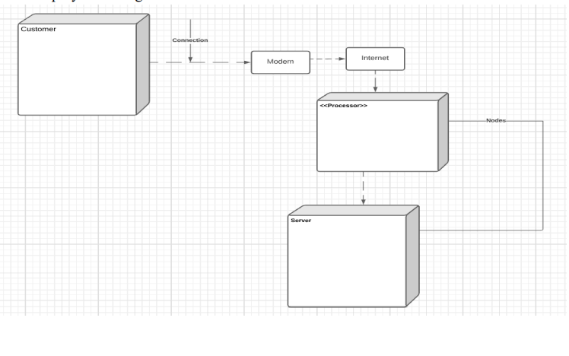

**9.COMPONENT DIAGRAM**

